PROJECT REPORT
FinWise AI
Intelligent Loan Eligibility, Credit Analysis & Financial Advisory Platform
SmartBridge Vibe Coding Internship (SIP 2026) - SRM University AP
Team Members | Role
Jainesh Bharti | Frontend Development + AI Integration
Navneeth Biyyapu | Frontend Development + Google Sheets Integration
Vishnu Vardhana Reddy Paluvai | Frontend Development + UI Development

1. Introduction

1.1 Project Overview
FinWise AI is a smart, AI-powered BFSI (Banking, Financial Services & Insurance) web platform built to simplify financial decision-making. It provides users with an intelligent loan-eligibility checker, a credit-score analyzer, an EMI calculator, and AI-generated financial guidance - all within a single, responsive web interface, with no login required. It is deployed as a static site on GitHub Pages and uses Groq AI and Google Sheets (via Apps Script) as its only external services.

1.2 Purpose
The purpose of FinWise AI is to give individuals - especially first-time or under-banked borrowers - a free, instant, and easy-to-understand way to assess their loan eligibility, understand their credit standing, calculate accurate EMIs, and receive personalised financial advice, before they approach a bank or NBFC.

2. Ideation Phase

2.1 Problem Statement
PS No. | I am | Trying to | But | Because | Which makes me feel
PS-1 | a salaried individual planning to apply for a loan | find out whether I am eligible before applying | banks take days to respond, or reject me after a hard credit check | I don't know my eligibility criteria in advance | anxious and discouraged
PS-2 | a first-time borrower with thin credit history | understand my credit score and its impact | there is no free tool that classifies and explains my credit profile | credit bureaus/banks don't provide plain-language advisory | confused, lacking confidence

2.2 Empathy Map Canvas
Dimension | Details
Says / Thinks | "Am I even eligible?" - worried a rejection will hurt their credit score further; unsure which numbers matter most.
Does / Feels | Searches loan eligibility online, visits multiple bank sites, delays applying; feels anxious until given a clear result.
Pains / Gains | Pain: no single free tool for eligibility + credit + EMI + advice. Gain: instant, clear, personalised results building confidence.

2.3 Brainstorming
The team grouped ideas into four categories - Loan & Credit Tools, AI-Powered Advisory, Data & Automation, and UI/UX - then prioritised by impact vs. effort. Four ideas were rated highest priority (P0): the Loan Eligibility Checker, Credit Score Analyzer, EMI Calculator, and Groq AI-powered Financial Tips, with Google Sheets logging as a supporting (P1) feature.

3. Requirement Analysis

3.1 Customer Journey Map
Stage | User Action | Experience
Awareness | User needs a loan / wants to check finances | Searches online for eligibility/credit tools
Consideration | Lands on FinWise AI landing page | Sees clear feature cards: Eligibility, Credit Score, EMI, AI Tips
Interaction | Fills in the Eligibility / Credit Score / EMI form | Gets an instant, rule-based result with no signup
AI Guidance | Opens AI Financial Tips | Receives a personalised recommendation from Groq AI within seconds
Follow-up | Result is logged to Google Sheets in the background | User can revisit anytime; team can analyse aggregate trends

3.2 Solution Requirement (Functional & Non-Functional)
FR No. | Requirement (Epic) | Details
FR-1 | User Data Entry | Enter salary, age, credit score, existing EMI with client-side validation
FR-2 | Loan Eligibility Check | Rule-based check; eligible amount = Salary x 20
FR-3 | Credit Score Analysis | Classify into Excellent / Good / Poor with tips
FR-4 | EMI Calculator | Reducing-balance EMI formula with amortisation summary
FR-5 | AI Financial Tips | Groq AI-generated personalised guidance
FR-6 | Data Logging | POST results to Google Apps Script -> Google Sheets
NFR | Description
Usability | Single-page, no-signup forms; instant results without reload
Security | HTTPS delivery; no server-side storage of sensitive data
Performance | Rule-based results in <1s; AI tips in a few seconds
Availability | 24x7 via GitHub Pages static hosting
Scalability | Stateless frontend extendable with auth/backend later

3.3 Data Flow Diagram
User -> FinWise AI Frontend (validates input, runs rule engine) -> [Groq AI API for tips] and [Google Apps Script -> Google Sheets for logging] -> Result rendered back to the user instantly.

3.4 Technology Stack
Component | Technology
User Interface | HTML5, CSS3 (glassmorphism), Vanilla JavaScript
Application Logic | JavaScript rule engines: eligibility.js, credit-score.js, emi.js
AI Recommendation Engine | Groq AI Chat Completions API (LLaMA-based, free tier)
Data Storage | Google Sheets
Serverless Backend | Google Apps Script (Web App / doPost)
Hosting | GitHub Pages

4. Project Design

4.1 Problem - Solution Fit
Target users - first-time borrowers and salaried individuals - feel anxious and uninformed before applying for a loan, relying on scattered bank websites and generic advice. FinWise AI fits this behaviour by offering one instant, no-login destination that combines eligibility, credit and EMI checks with AI-generated guidance, leaving users confident and prepared.

4.2 Proposed Solution
Parameter | Description
Problem Statement | No free, instant way to check loan eligibility, credit standing or EMI before approaching a bank
Idea / Solution | A single-page platform combining Loan Eligibility, Credit Score Analysis, EMI Calculator and Groq AI Financial Tips
Novelty | Combines deterministic rule engines with generative-AI advice in one lightweight, no-login static app
Social Impact | Reduces rejection anxiety and helps under-banked users self-assess for free
Business Model | Freemium; potential lender-referral commissions or a premium credit-improvement report
Scalability | Can add auth, a real database, and more financial products over time

4.3 Solution Architecture
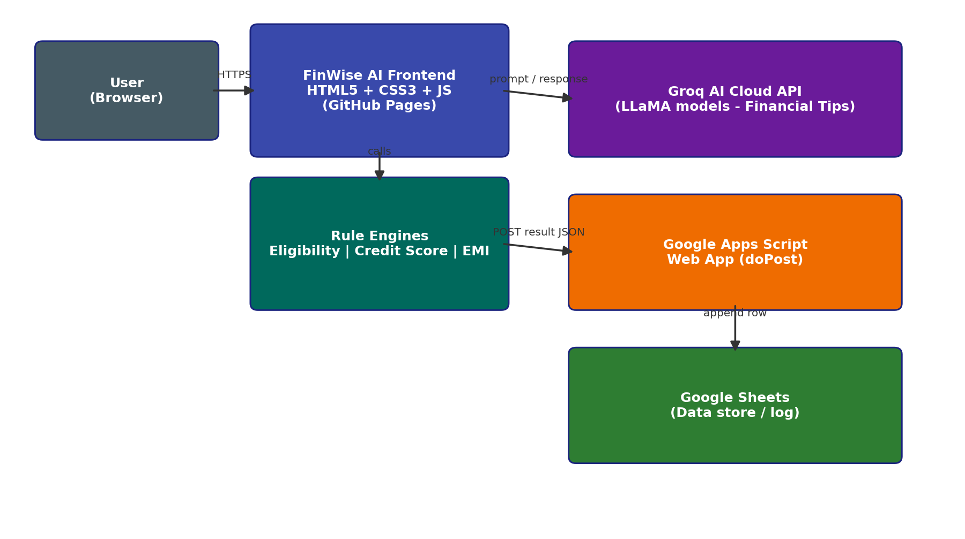

5. Project Planning & Scheduling

5.1 Project Planning
Sprint | Epic | Story | Story Points | Priority
Sprint-1 | Loan Eligibility | USN-1 | 3 | High
Sprint-1 | Credit Score | USN-2 | 3 | High
Sprint-1 | EMI Calculator | USN-3 | 2 | High
Sprint-2 | AI Financial Tips | USN-4 | 5 | Medium
Sprint-2 | Data Logging | USN-5 | 3 | Medium
Sprint-2 | Responsive UI | USN-6 | 2 | Low
Sprint-1: 8 story points completed (01-04 Jul 2026). Sprint-2: 10 story points completed (07-10 Jul 2026). Velocity = 18 / 2 = 9 story points per sprint.

6. Functional and Performance Testing

6.1 Performance Testing
Test Case | Scenario | Result
FT-02 | Loan eligibility rule evaluation | Pass - correct Eligible/Not Eligible + amount
FT-03 | Credit score classification | Pass - correct label for all ranges
FT-04 | EMI calculation accuracy | Pass - matched manual reducing-balance formula
FT-05 | AI Tips generation (Groq) | Pass - relevant tips generated
FT-07 | Google Sheets data logging | Pass - new row appended per submission
PT-01 | Rule-based response time | Pass - under 1 second
PT-02 | AI response time | Pass - ~2-4 seconds average

7. Results

7.1 Output Screenshots
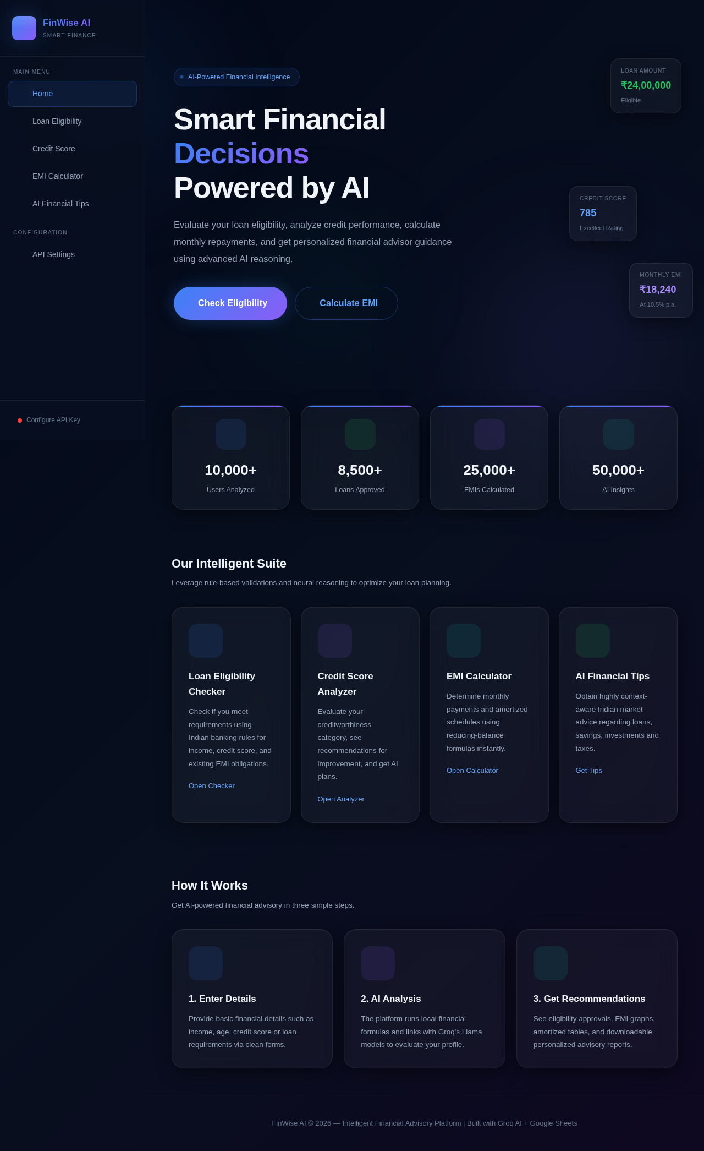
Landing dashboard with quick eligibility, credit score and EMI snapshots.
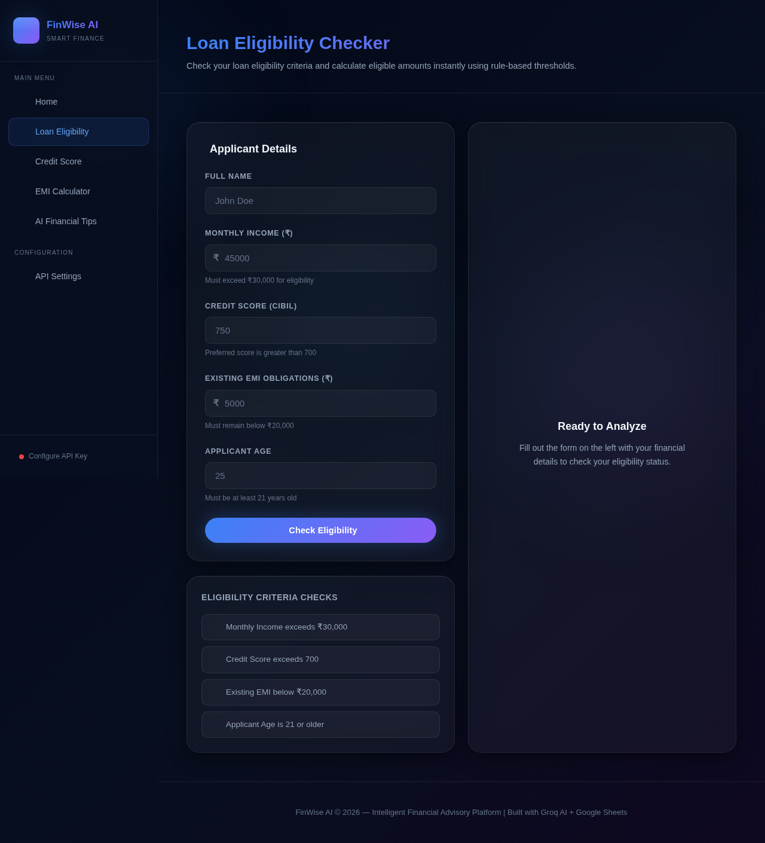
Loan Eligibility Checker with real-time criteria checks.
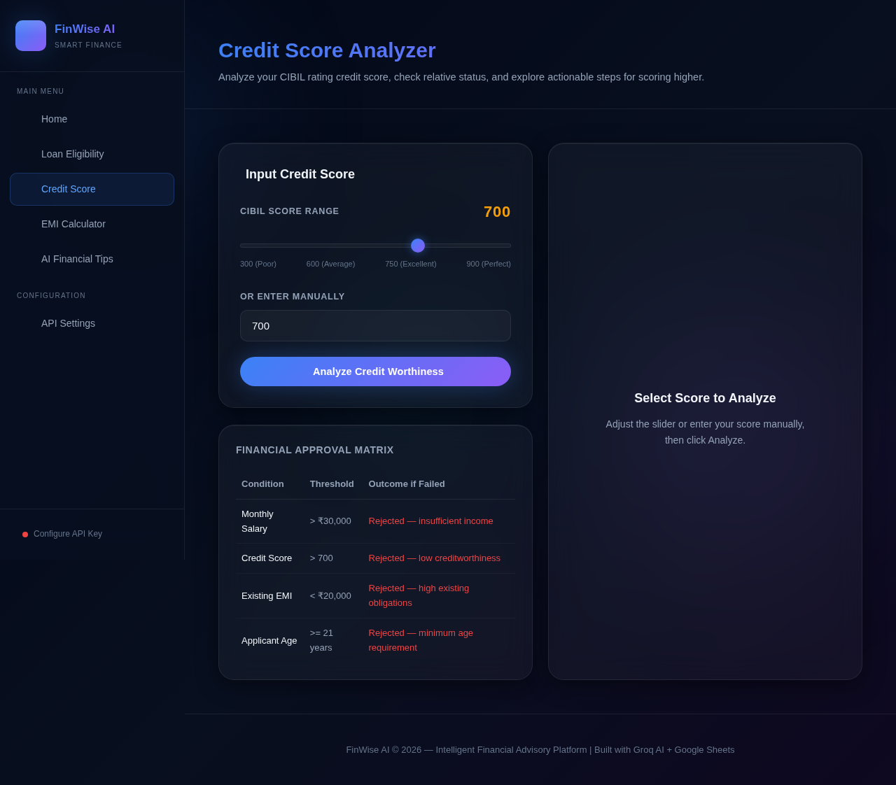
Credit Score Analyzer.
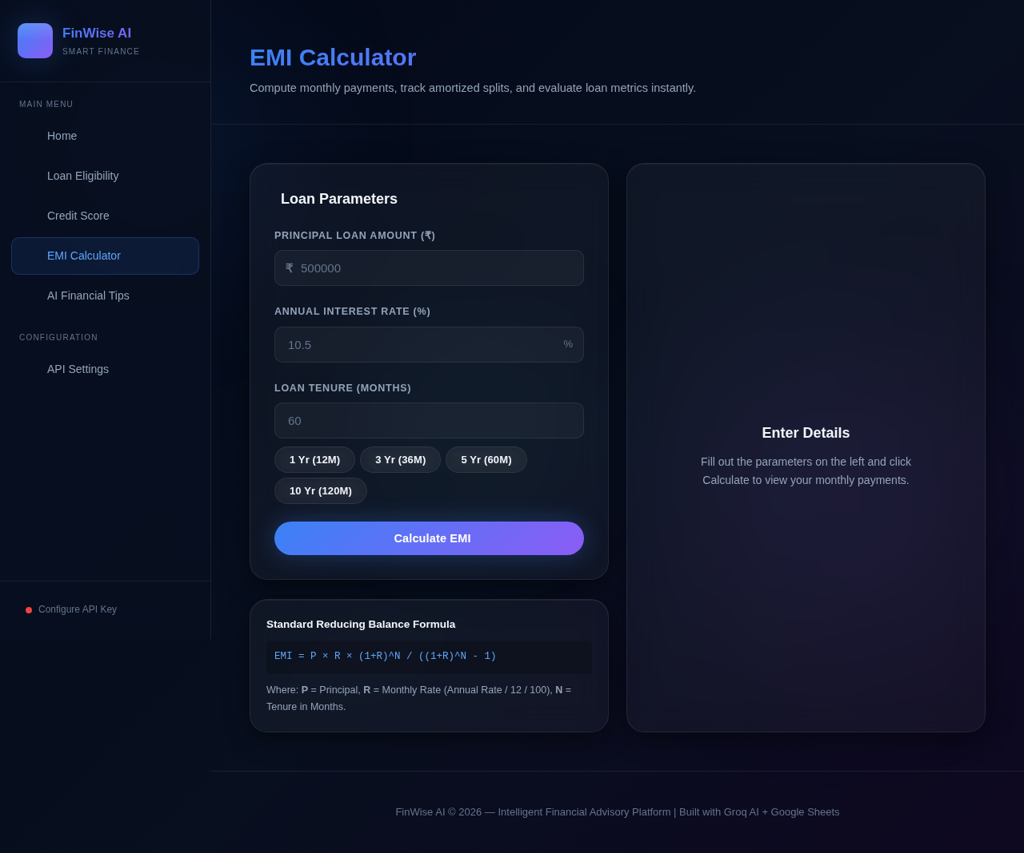
EMI Calculator using the reducing-balance method.
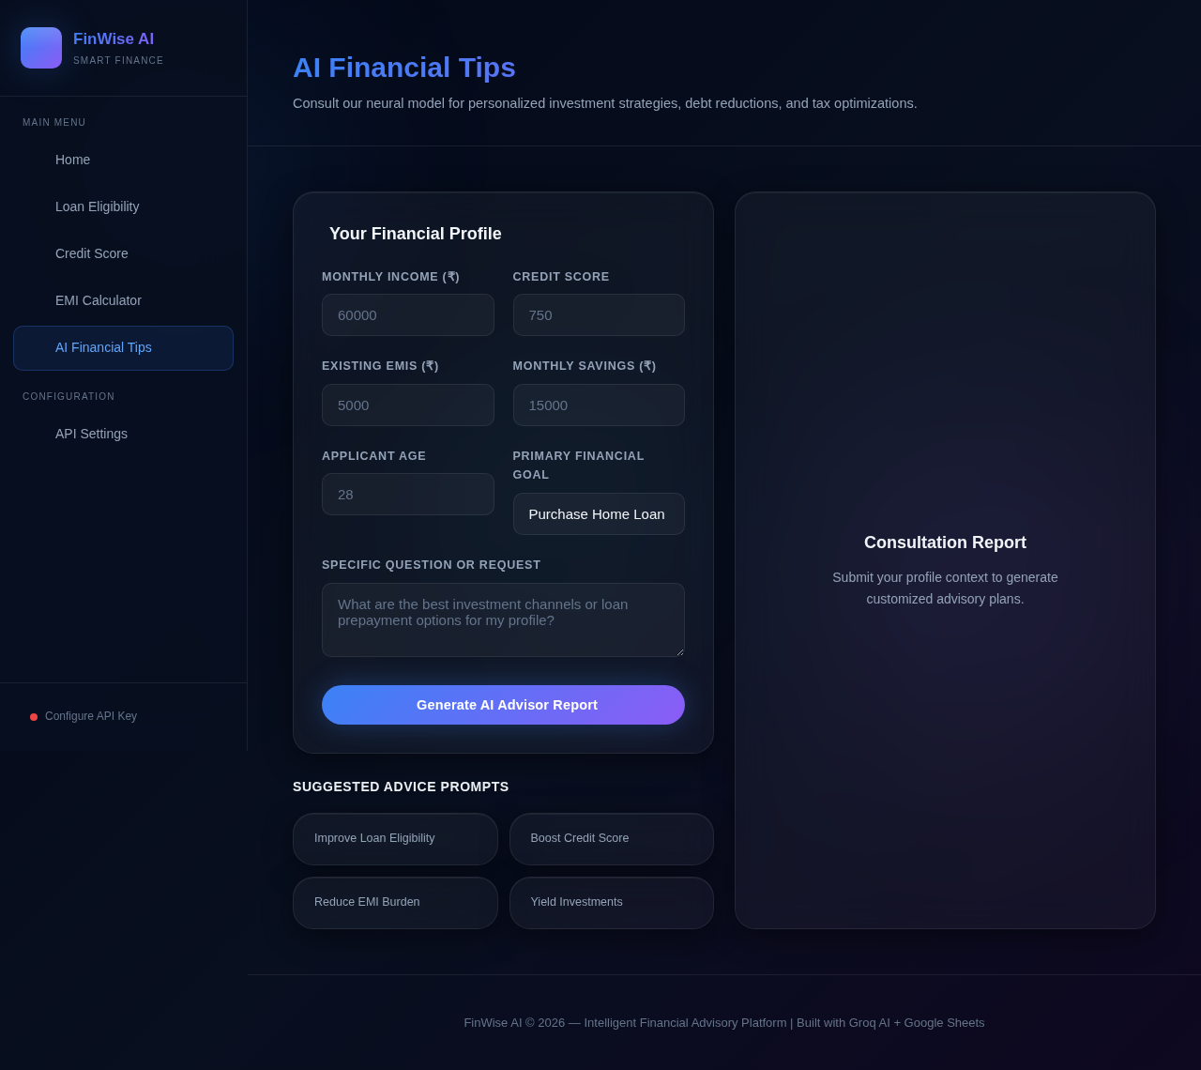
AI Financial Tips powered by the Groq API.

8. Advantages & Disadvantages
Advantages:
- Free, instant, no-signup access to eligibility, credit and EMI checks
- Combines deterministic rule engines with generative-AI guidance in one app
- Lightweight static architecture - fast, cheap to host, and easy to maintain
- Mobile-responsive glassmorphism UI works across devices
Disadvantages:
- No server-side validation, so it complements rather than replaces a bank's formal assessment
- Requires the user to supply their own Groq API key for AI Tips
- No persistent user accounts, so history isn't tracked per individual user

9. Conclusion
FinWise AI successfully demonstrates how a lightweight, serverless web application can combine rule-based financial logic with generative AI to deliver a genuinely useful, free BFSI advisory tool. Built entirely with HTML5, CSS3 and vanilla JavaScript and integrated with the Groq AI API and Google Sheets, the platform was designed, developed, tested and deployed by the team within the SmartBridge SIP 2026 internship timeline, meeting all the functional requirements identified during Requirement Analysis.

10. Future Scope
- User accounts to track eligibility/credit history over time
- A secure backend layer to manage the Groq API key server-side
- Downloadable PDF reports of eligibility, credit and EMI results
- Multi-language support and a conversational chatbot interface
- Partnership integrations with NBFCs for pre-qualified loan referrals

11. Appendix
Source Code: index.html, eligibility.html, credit-score.html, emi.html, tips.html, css/style.css, js/*.js, google-apps-script.gs (see GitHub repository).
Dataset Link: Not applicable - FinWise AI uses rule-based logic and live AI inference rather than a static training dataset; submitted user data is logged to Google Sheets.
GitHub Repository: https://github.com/JaineshBharti5/finwise-ai
Live Demo: https://jaineshbharti5.github.io/finwise-ai
Demo Video: https://drive.google.com/file/d/1R7yStCQXAuEFCktQstJzgT8etC3Lp7Fr/view?usp=sharing

